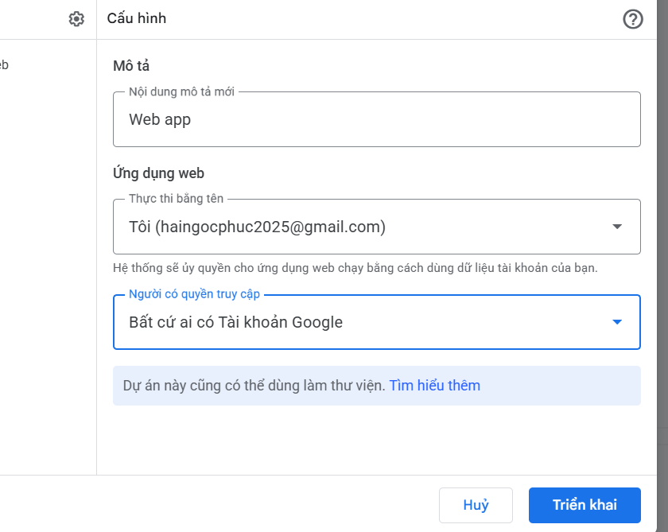

ID triển khai
AKfycby2uEIvbRX79Me_egWXqlv8YfkbUeCCBnIhNa9y5pQZMcgrRzXl_QMjZKa7Ga4hy7o6

https://script.google.com/macros/s/AKfycby2uEIvbRX79Me_egWXqlv8YfkbUeCCBnIhNa9y5pQZMcgrRzXl_QMjZKa7Ga4hy7o6/exec

AKfycbwVf0ft1nCwezmG10Fy2j8bqeVyVlpJjAf__FtLvKcMXcH2KNPGvjYtt94-oP-u5ffk

https://script.google.com/macros/s/AKfycbwVf0ft1nCwezmG10Fy2j8bqeVyVlpJjAf__FtLvKcMXcH2KNPGvjYtt94-oP-u5ffk/exec

https://script.google.com/macros/s/AKfycbz0gNqKkLzp4xuVdW7BoaKuiIVltf9_AOrHml7vsLVxz7zxwT0r5hT1-ebMzUrpnnfW/exec

